


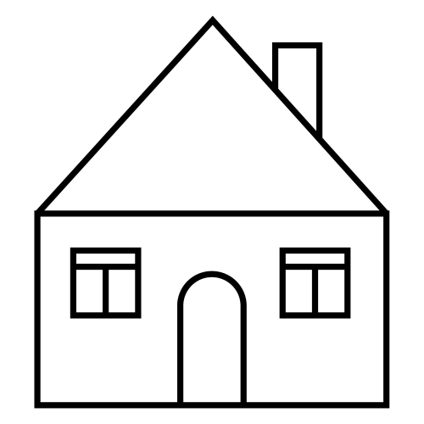 | 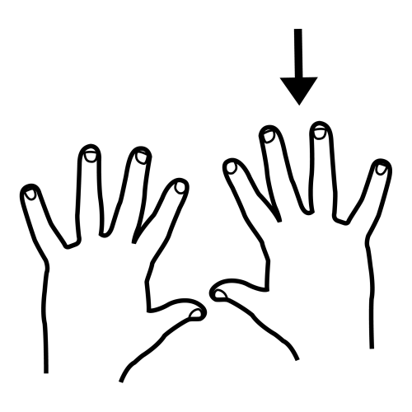 | 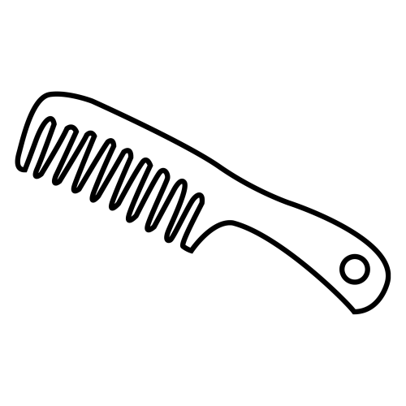 | 
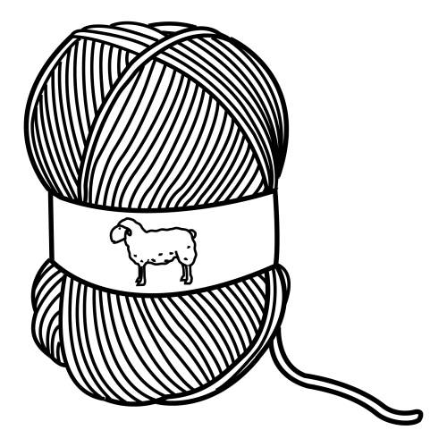 | 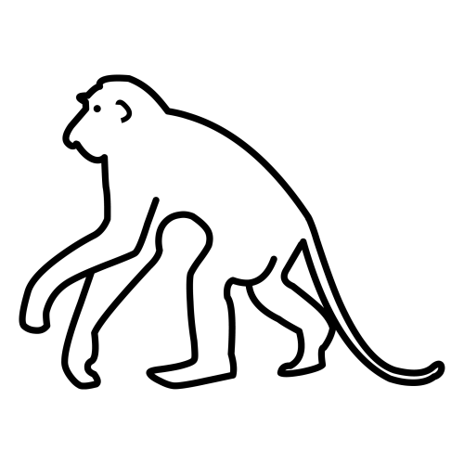 | 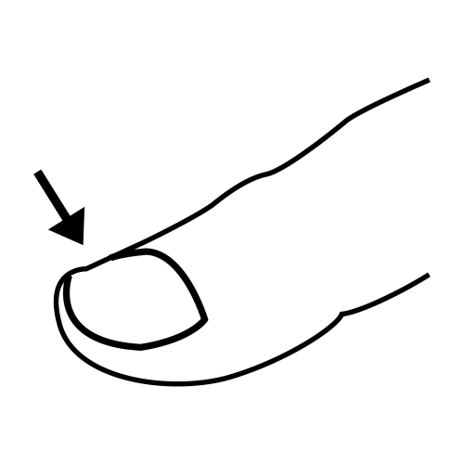 | 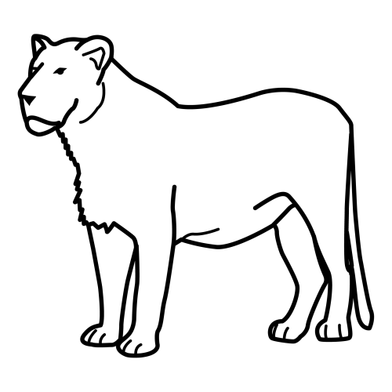



 |  |  |  |  |  | 
 |  |  |  |  |  | 
 |  |  |  |  |  | 
 |  |  |  |  |  | 



 |  |  |  |  |  | 
 |  |  |  |  |  | 
 |  |  |  |  |  | 
 |  |  |  |  |  | 

N

 | 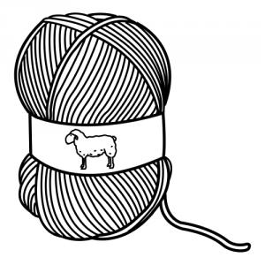 |  | 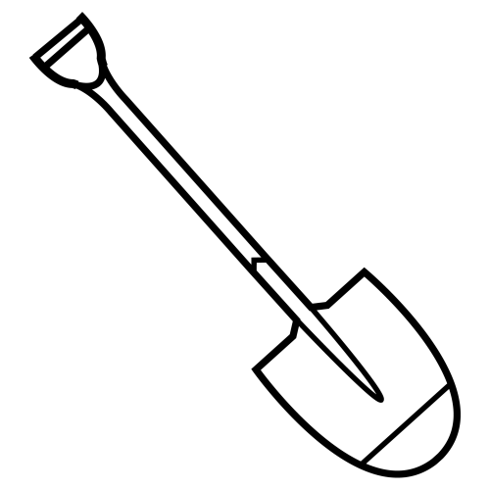
MONO | LANA | LEONA | PALA
 | 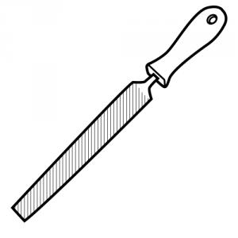
MANO | LIMA | PEINE | LUPA


 |  |  | 
 |  |  | 

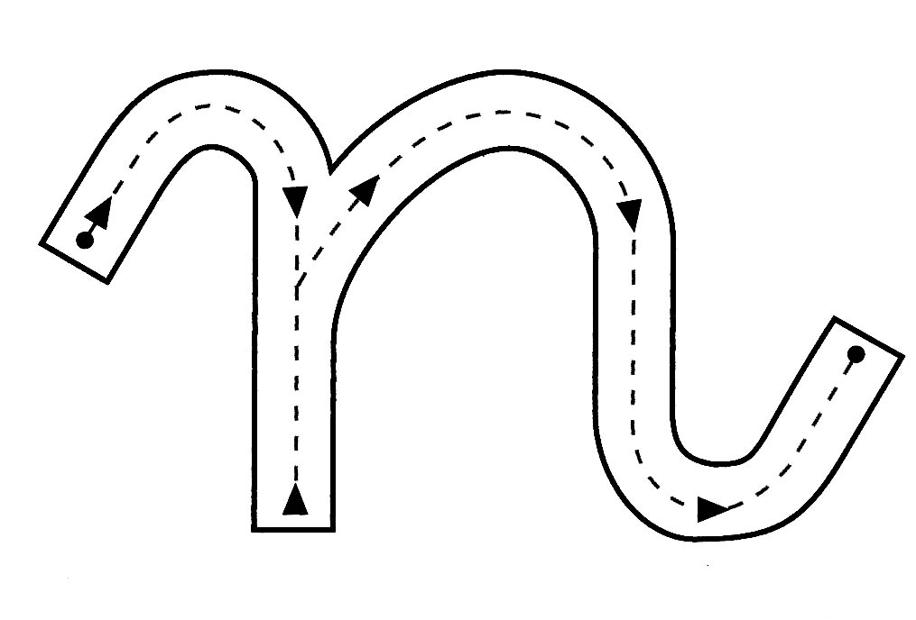






MONO |  | 
PEINE |  | 
LANA |  | 
MANO |  | 
LEONA |  | 

 |  | 
 |  | 
 |  | 
 |  | 
 |  | 

 | MONO | 
 | PEINE | 
 | LANA | 
 | MANO | 
 | LEONA | 

 |  | 
 |  | 
 |  | 
 |  | 
 |  | 

asocia y escribe
 |  | PEINE | ____________ ____________
 |  | MONO | ________ ________ ________
 |  | LEONA | ____________ ____________
 |  | LANA | ____________ ____________
 |  | MANO | ____________ _____________

asocia y escribe
 |  |  | ____________ ____________
 |  |  | ________ ________ ________
 |  |  | ____________ ____________
 |  |  | ____________ ____________
 |  |  | ____________ _____________















