


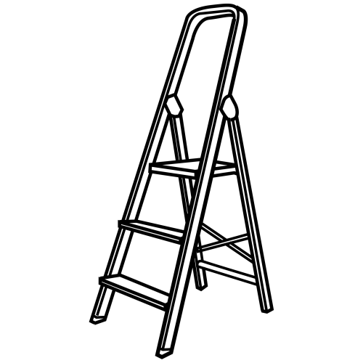 |  |  | 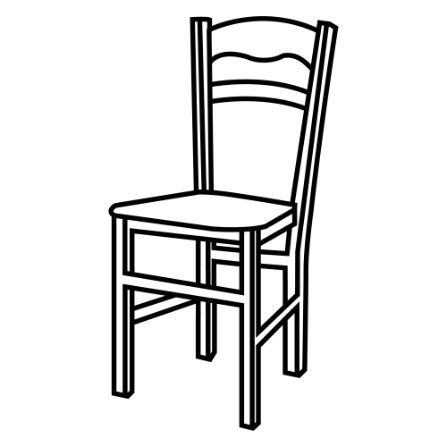
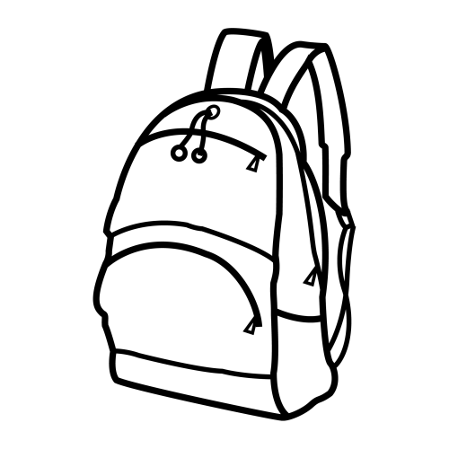 | 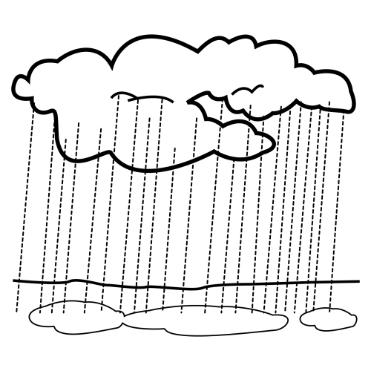 |  | 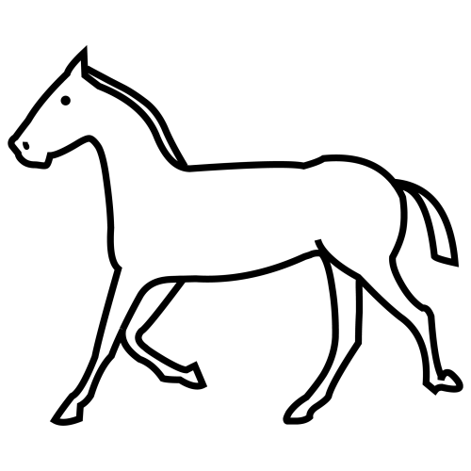



 |  |  |  |  |  | 
 |  |  |  |  |  | 
 |  |  |  |  |  | 
 |  |  |  |  |  | 

LL

 |  |  | 
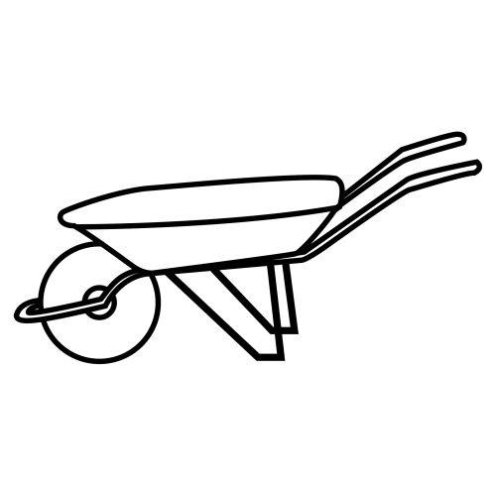
 |  |  | 



 |  |  | 
 |  |  | 

 |  | 
 |  |   
 |  | 
 |  | 

 |  | 
 |  |   
 |  | 
 |  | 

asocia y escribe
 |  | 
 |  |   
 |  | 
 |  | 

asocia y escribe
 |  | 
 |  |   
 |  | 
 |  | 

 |  | LLUVIA SILLA LLAVE LLUVIA
 |  | SILLA LLUVIA SILLA LLORA SILLA
 |  |  LLORA LLUVIA LLAVE LLORA
 |  |  LLUVIA LLORA LLAVE LLAVE

 |  | 
 |  | 
 |  | 
 |  | 

escribe

 |  | 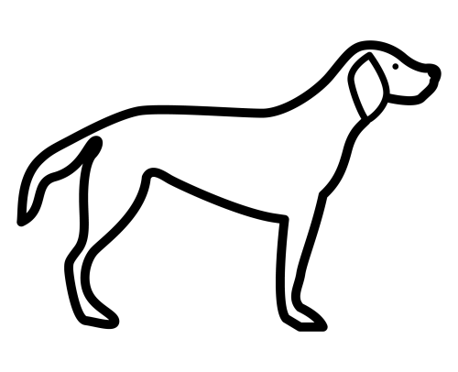 |  |  |  | 

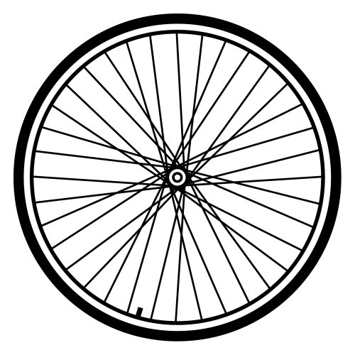 |  |  |  |  |  | 

