
 CA CO CU

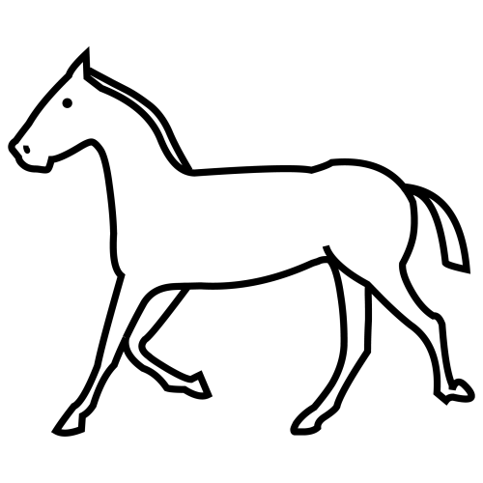 | 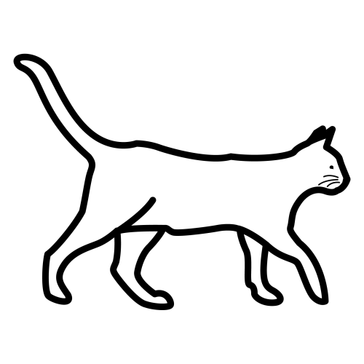 |  | 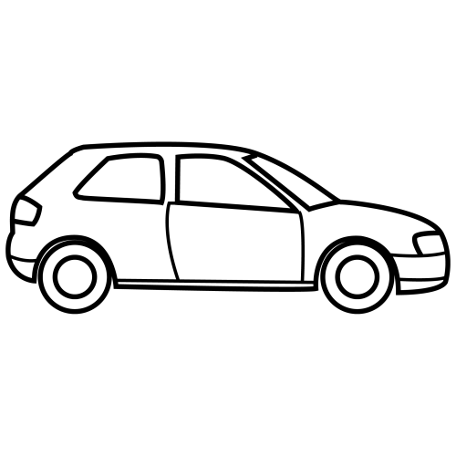
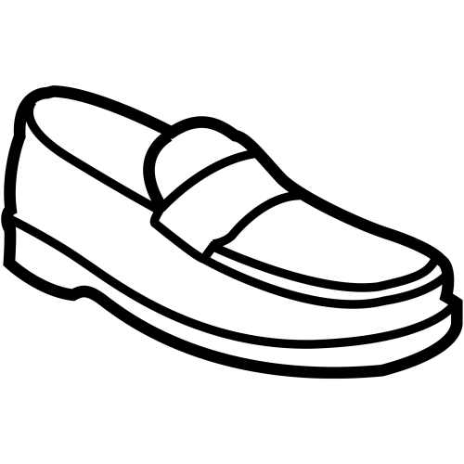 |  | 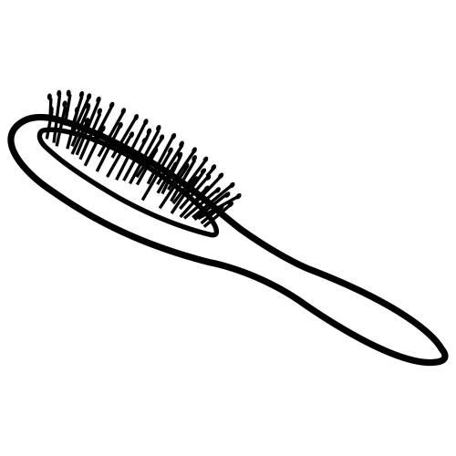 | 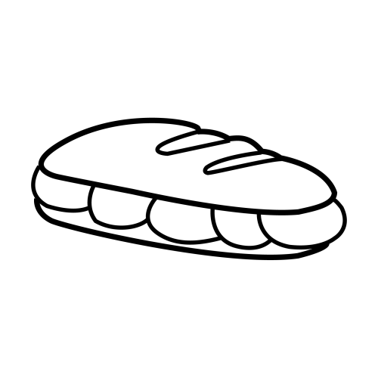

 QUE QUI

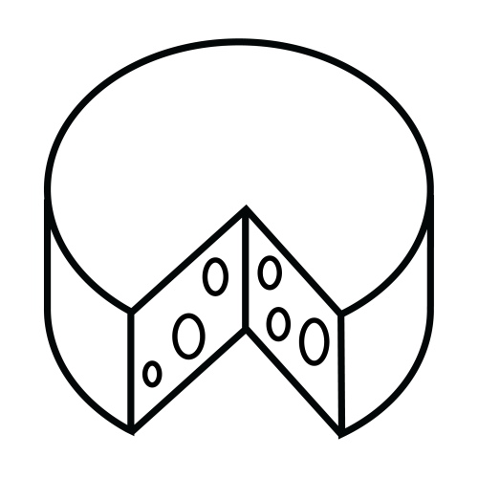 | 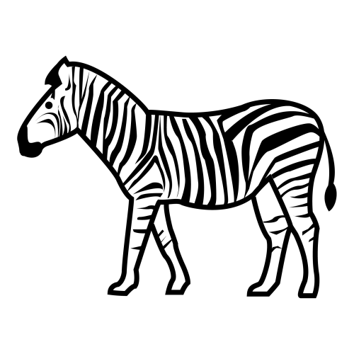 | 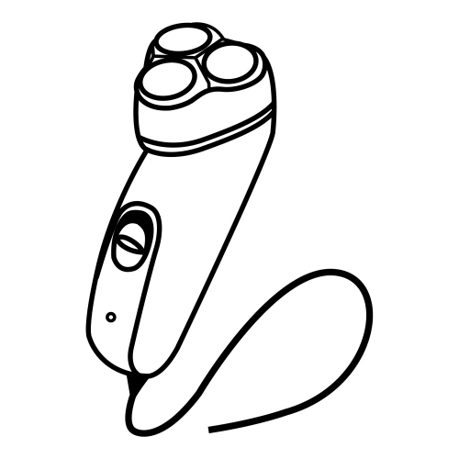
 | 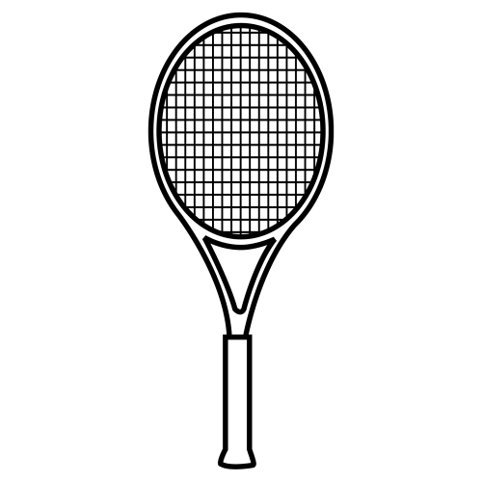 |  | 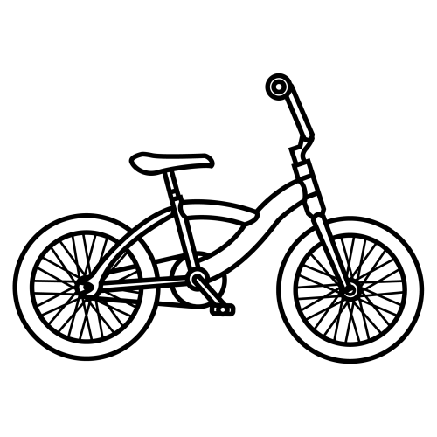

 

 |  |  |  |  |  | 
 |  |  |  |  |  | 
 |  |  |  |  |  | 
 |  |  |  |  |  | 



 |  |  |  |  |  | 
 |  |  |  |  |  | 
 |  |  |  |  |  | 
 |  |  |  |  |  | 



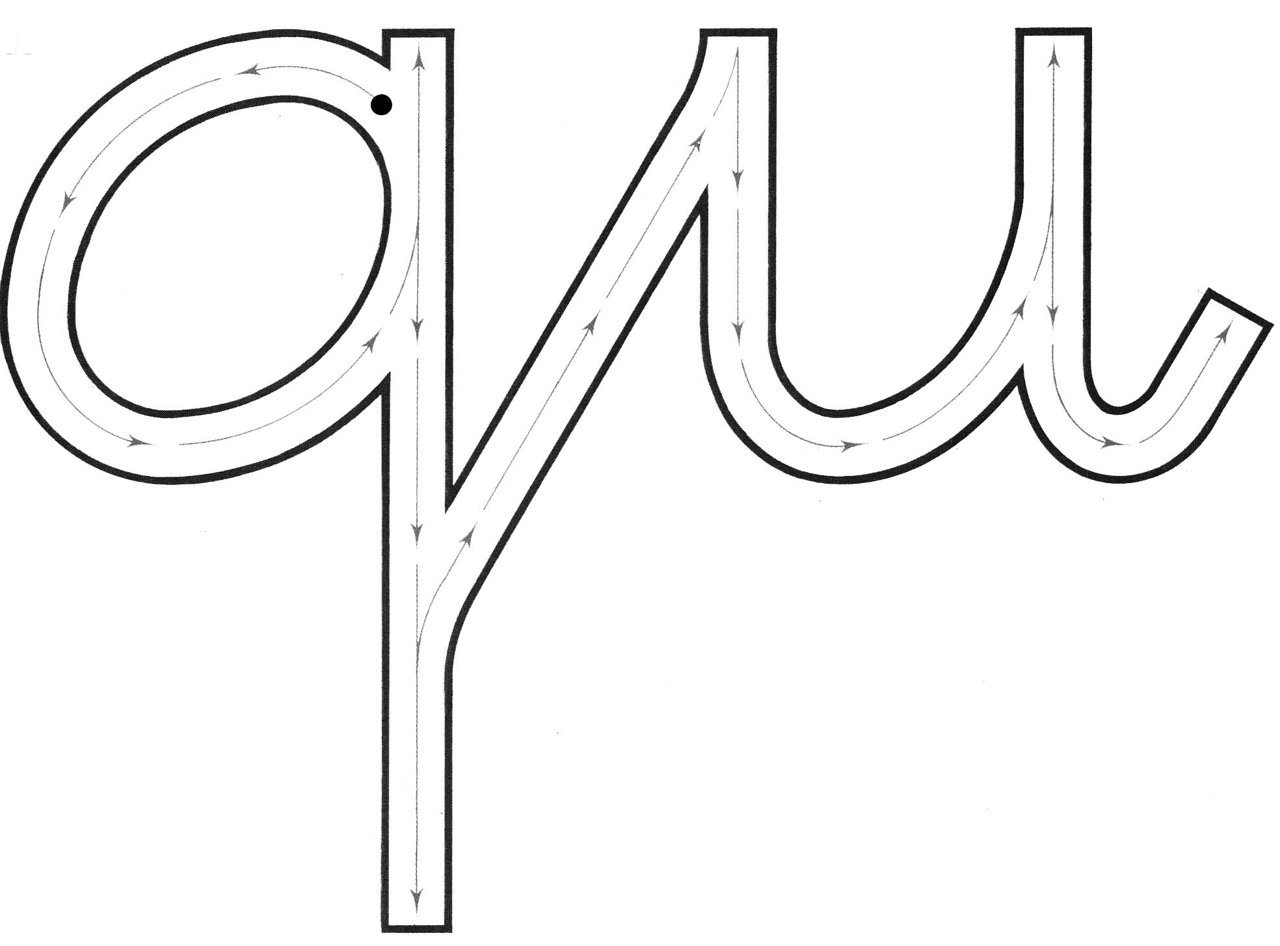

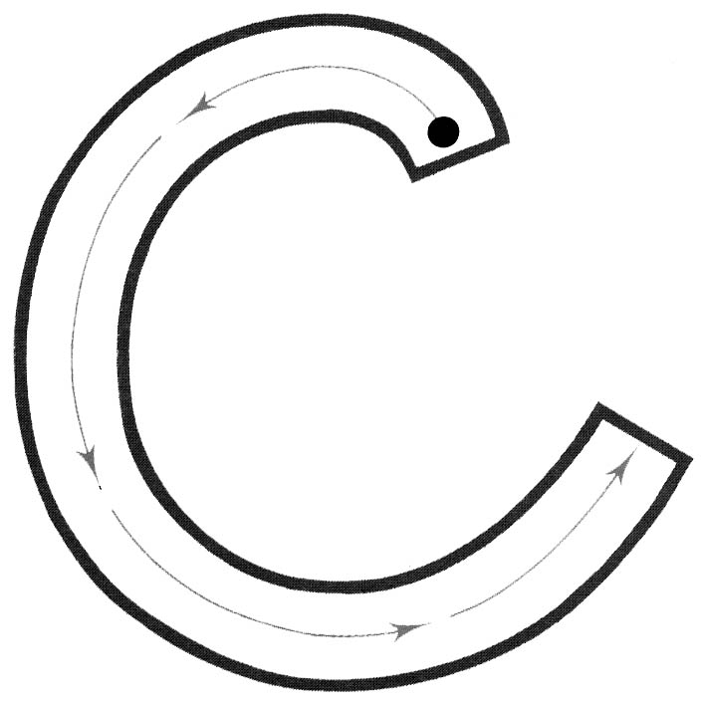



 |  | 
 |  |   
 |  | 
 | 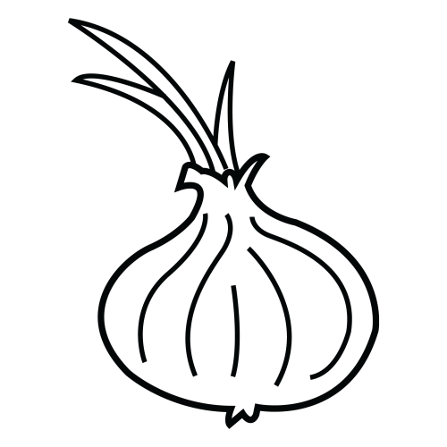 | 

 |  | 
 | 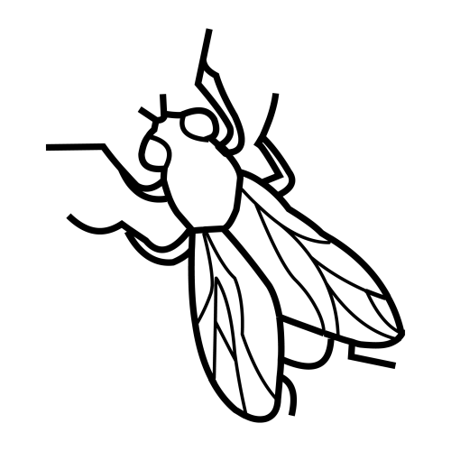 |   
 |  | 
 |  | 

asocia y escribe
 |  | 
 |  |   
 |  | 
 |  | 

asocia y escribe
 |  | 
 |  |   
 |  | 
 |  | 

asocia y escribe
 |  | 
 |  |   
 |  | 
 |  | 

asocia y escribe
 |  | 
 |  |   
 |  | 
 |  | 

 |  |  |  | 
 |  |  |  | 

 |  |  | 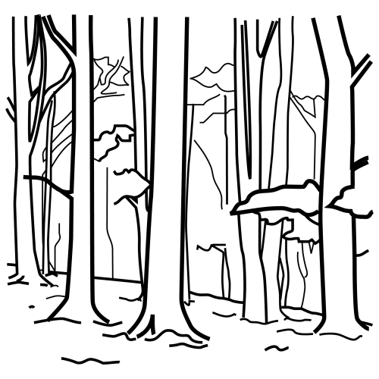

escribe



