A 

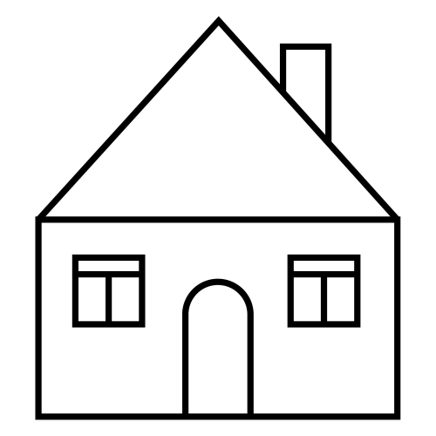 | 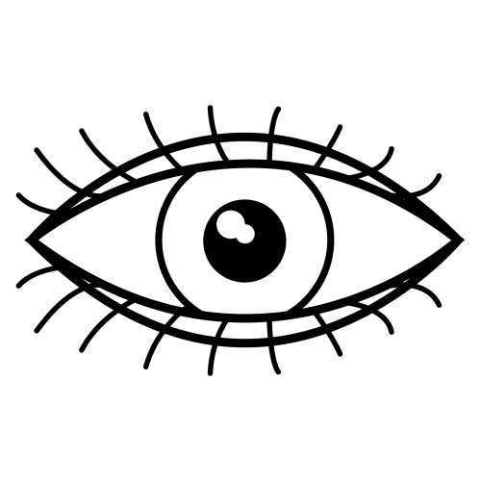 | 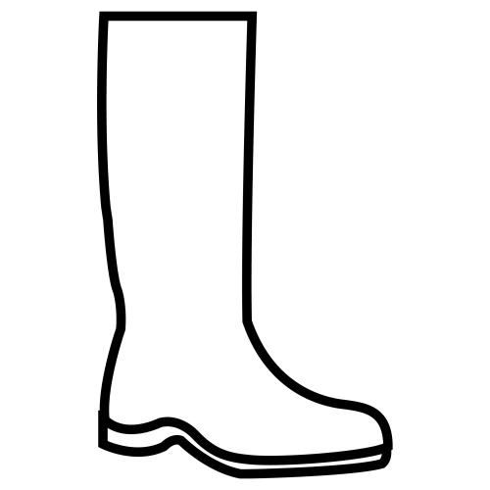 | 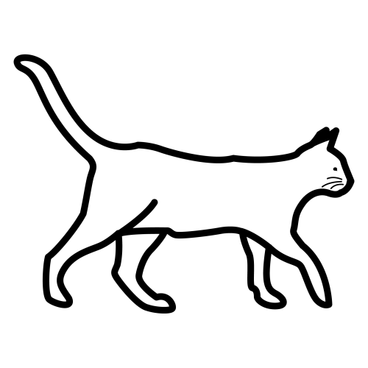
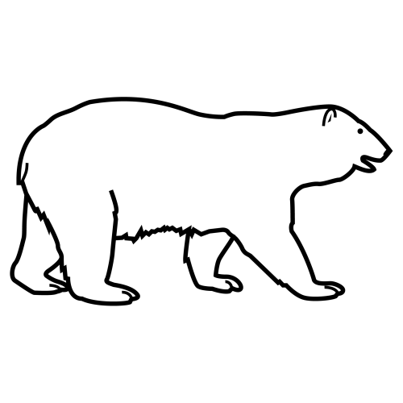 | 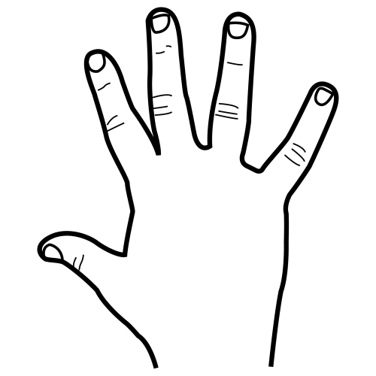 | 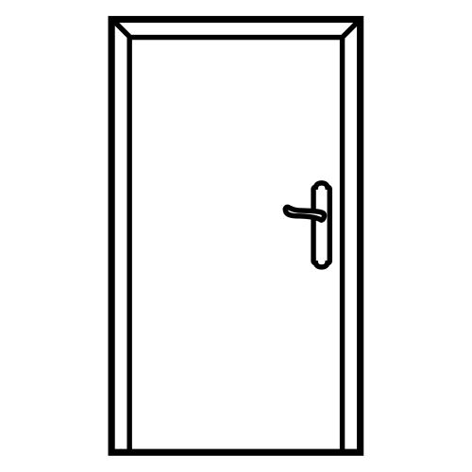 | 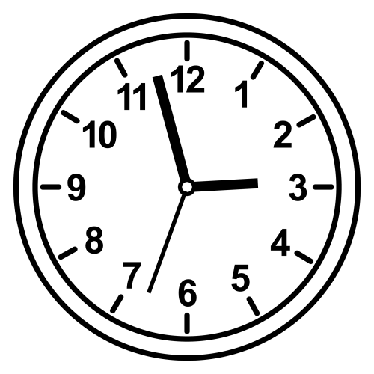



 |  |  |  |  | 
 |  |  |  |  | 
 |  |  |  |  | 
 |  |  |  |  | 


 |  |  |  |  | 
 |  |  |  |  | 
 |  |  |  |  | 
 |  |  |  |  | 
A

CASA | OJO | PUERTA | GATO
OSO | MANO | BOTA | RELOJ


 |  |  | 
 |  |  | 



