L E O N A | M E S A | P A L A
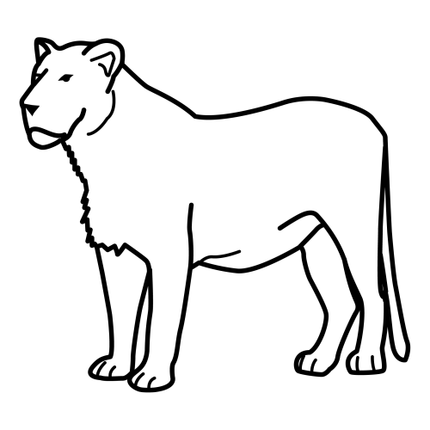 | 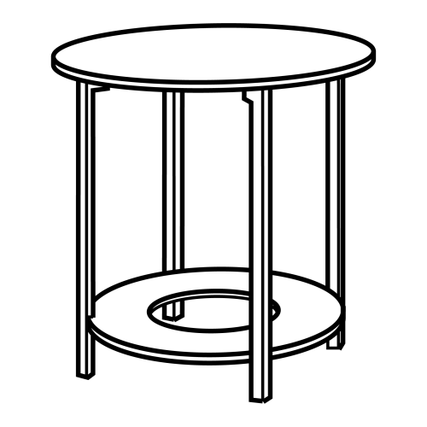 | 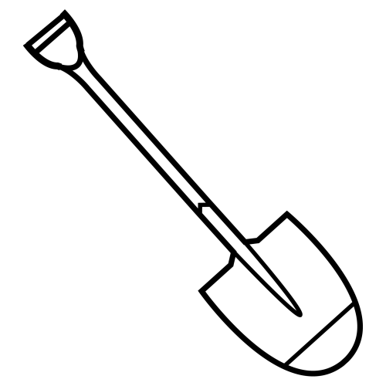
L E O N _ | _ E S A | P A L _
_ _ O N A | M E _ _ | _ _ L A
L E O _ _ | _ _ S A | P _ L _
_ _ _ N A | M _ _ _ | P _ _ _
_ _ _ _ _ | _ _ _ _ | _ _ _ _

LUPA | MONO | PEINE
 | 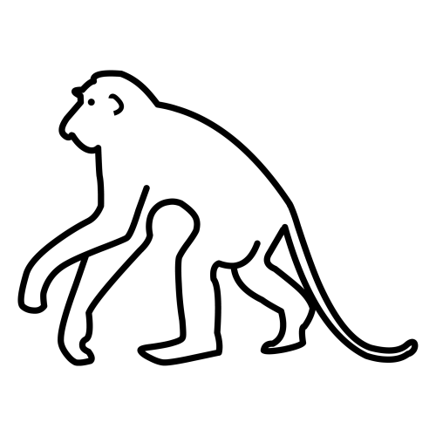 | 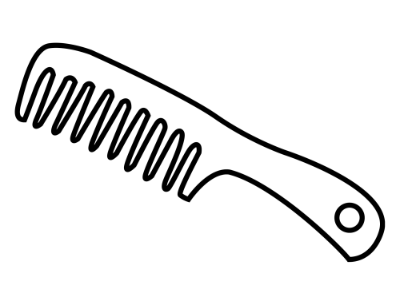
LUP_ | MON_ | PEI__
_UP_ | M_N_ | _EI__
__PA | __NO | __I__
__P_ | __N_ | P_I__
____ | ____ | _____

MANO | SOPA | SUMA
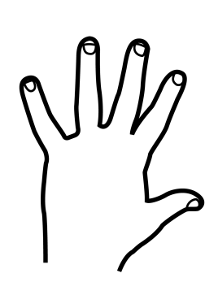 | 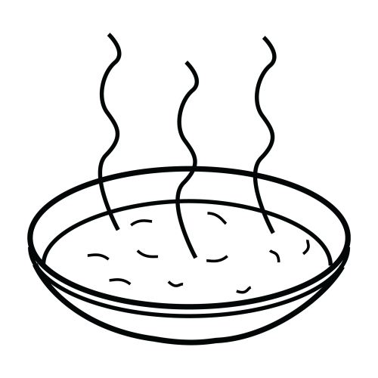 | 3 + 2
MAN_ | S_PA | S_MA
M_N_ | __PA | __MA
__N_ | __P_ | S__A
_A__ | S___ | ___A
____ | ____ | ____

LIMA | PALOMA | PELO
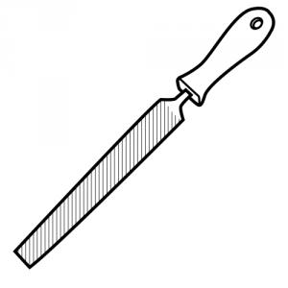 | 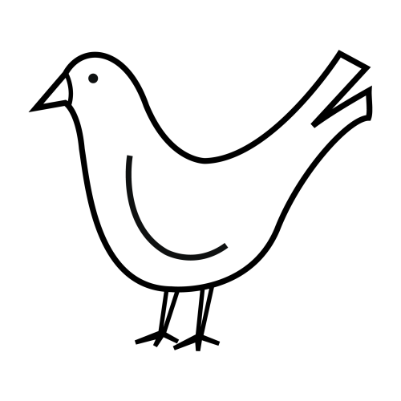 | 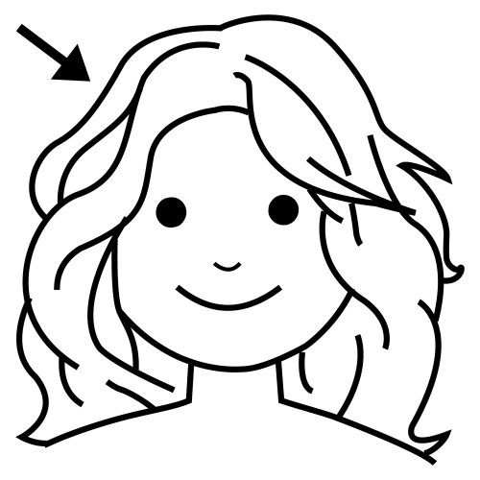
LIM_ | P_LOM_ | P_LO
_IM_ | __L_M_ | P__O
LI__ | P__O__ | ___O
_I__ | ___O__ | _E__
____ | ______ | ____

BEBÉ | BAILE | BOTA
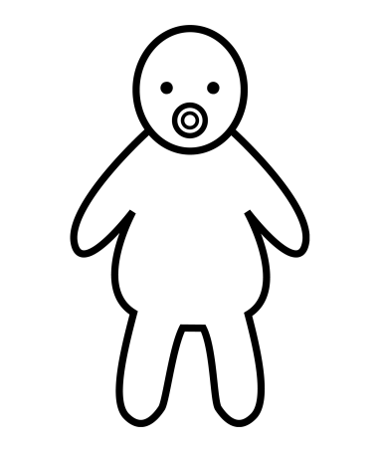 | 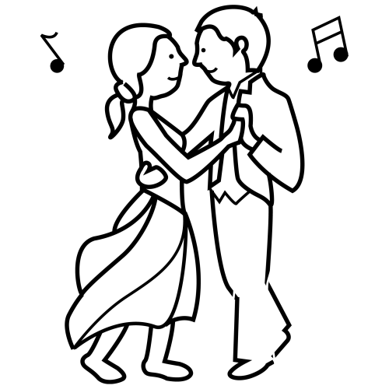 | 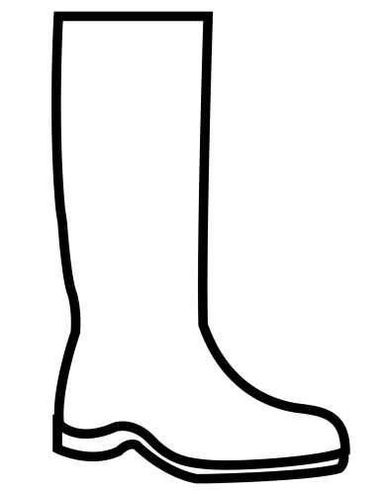
BEB_ | BAIL_ | B_TA
B_B_ | BA_L_ | B_T_
B___ | _A_L_ | __T_
___É | __I_E | _O__
____ | _____ | ____

NIDO | MANO | DOMINÓ
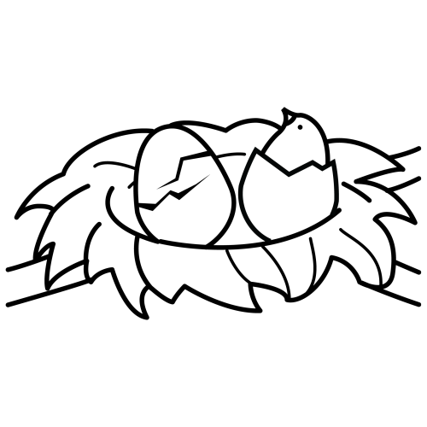 |  | 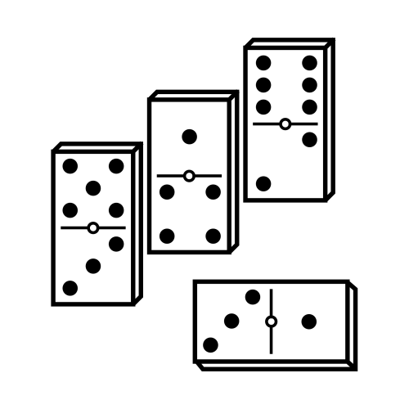
_IDO | _ANO | _OMINÓ
_ID_ | _A_O | _O_IN_
N_D_ | M__O | DO_I__
N___ | M___ | D_____
____ | ____ | ______

BATA | DUELE | BUTANO
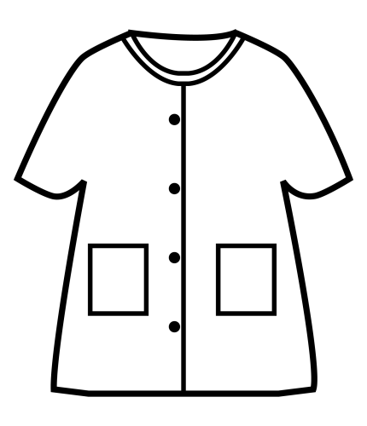 | 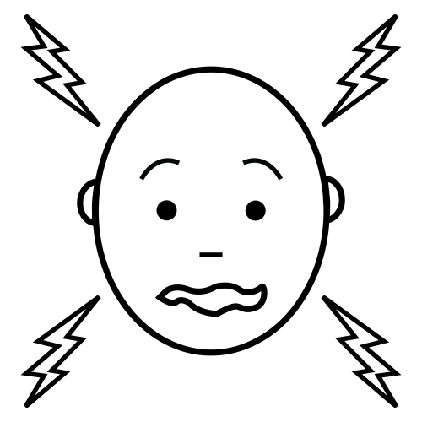 | 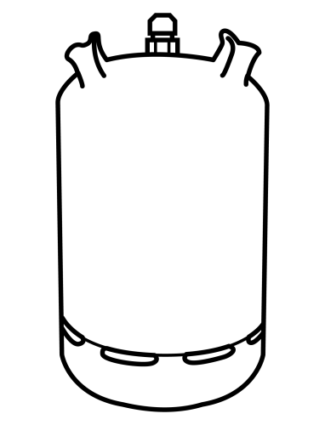
BA_A | D_ELE | BU_AN_
B__A | D_E_E | _UTA__
___A | _U__E | _U___O
__T_ | DU___ | B____O
____ | _____ | ______

DEDO | MALETA | MONEDA
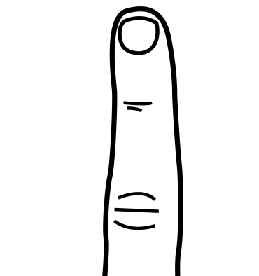 | 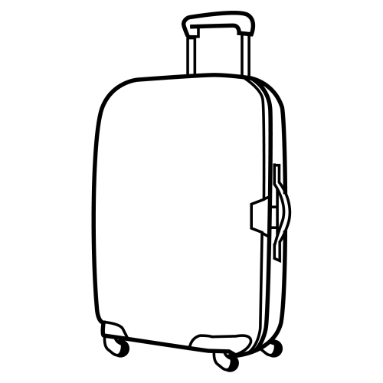 | 
DED_ | MA__TA | M__EDA
_ED_ | _AL__A | M_NE_A
__DO | __LE_A | _ON__A
__D_ | __L___ | _O____
____ | ______ | ______

SETA | PATO | LUPA
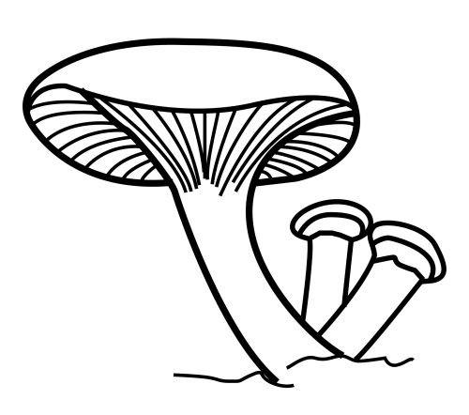 | 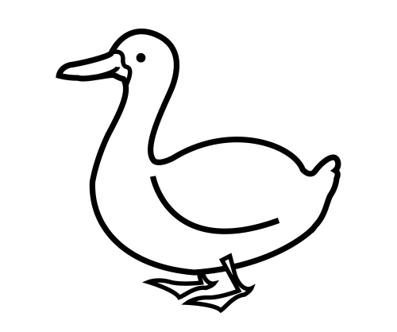
SET_ | P_TO | L_PA
S_T_ | P_T_ | L_P_
S__A | _AT_ | LU__
___A | _A__ | _U__
____ | ____ | ____

PELOTA | TOMATE | MONO
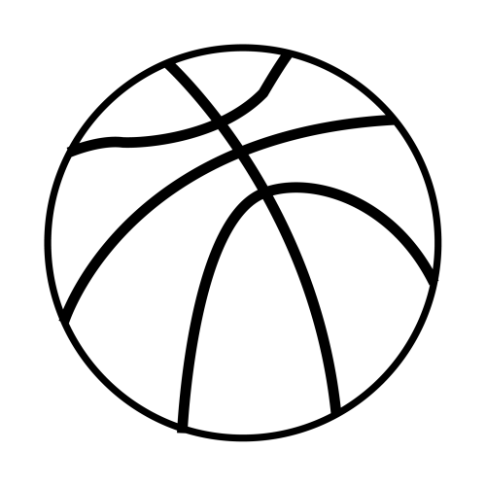 | 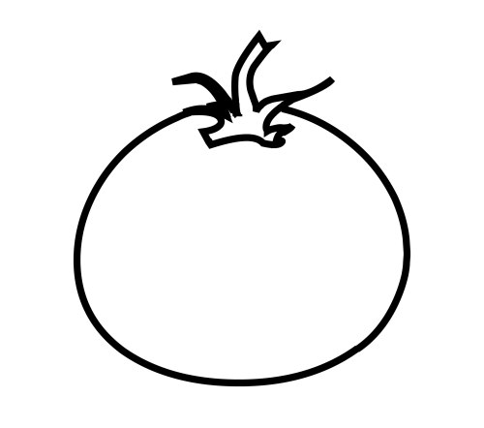
PE__TA | TO__TE | MO_O
_E_OT_ | _O_AT_ | _O_O
___O__ | _O_A__ | ___O
__L___ | __M___ | __N_
______ | ______ | ____

FAMILIA | FILA | FOTO
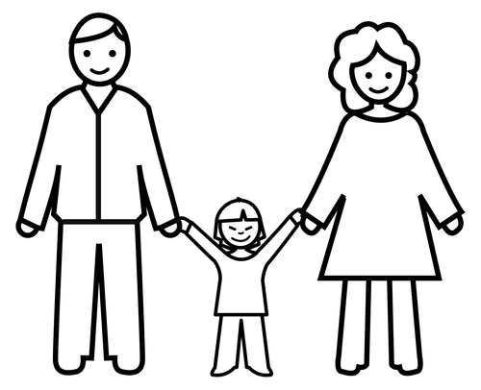 | 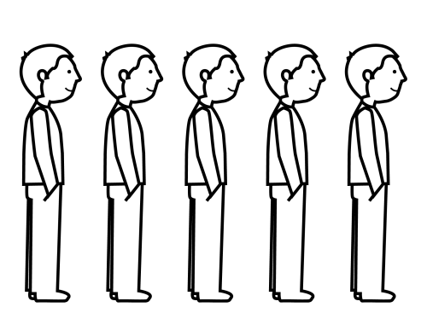 | 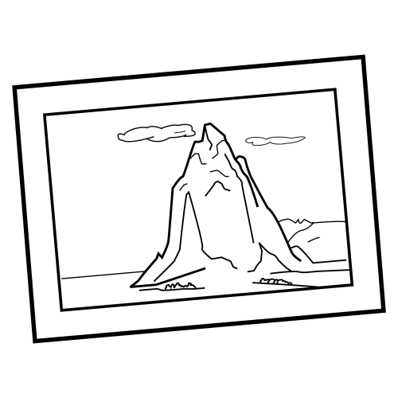
F_MILIA | FIL_ | _OTO
F_MI__A | F_L_ | _OT_
_AMI___ | __LA | F_T_
___I___ | ___A | F___
_______ | ____ | ____

OJO | VELA | HUEVO
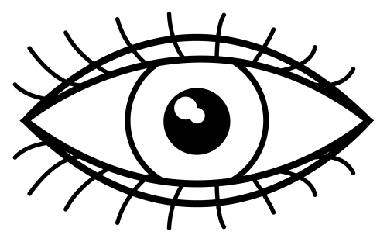 | 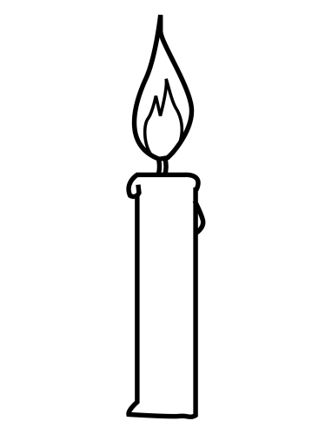 | 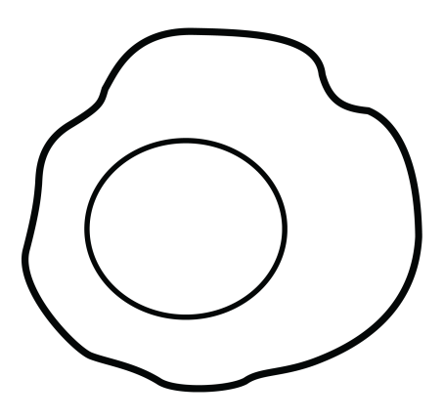
OJ_ | VEL_ | HUEV_
_J_ | V_L_ | __EV_
__O | ___A | ____O
O_O | V___ | H____
___ | ____ | _____

SOFÁ | JAULA | OVEJA
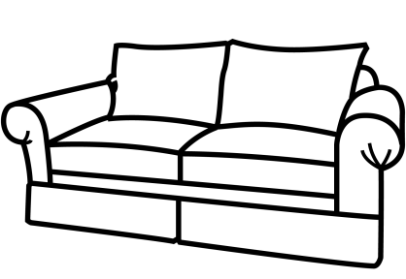 | 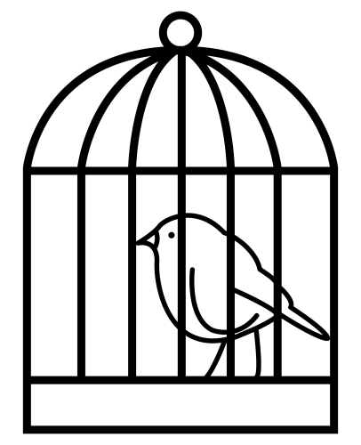 | 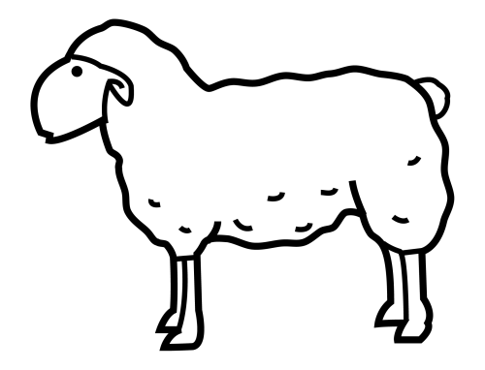
SOF_ | JAU_A | OVE_A
S_F_ | _AU_A | O_E_A
___Á | ___LA | ___JA
_O__ | ___L_ | _V_J_
____ | _____ | _____

JABALÍ | JUDÍA | UVA
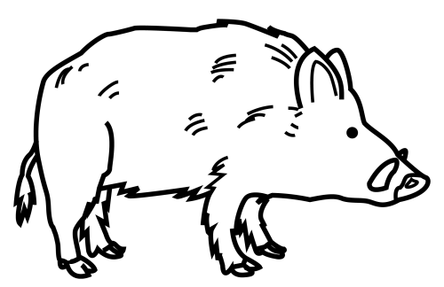 | 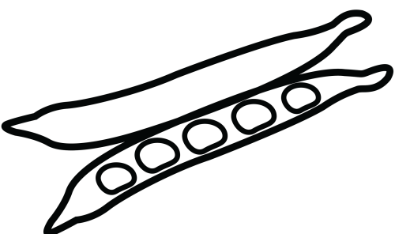 | 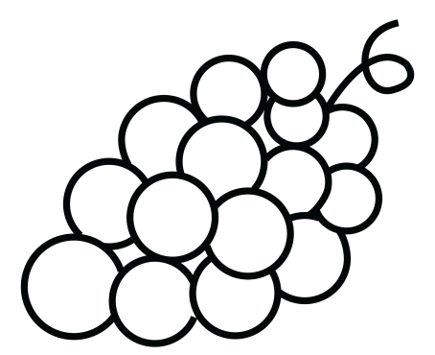
JABAL_ | JUD_A | _VA
JABAL_ | JUD_A | __A
__B_LÍ | __DÍ_ | _V_
__B___ | J__Í_ | U__
______ | _____ | ___

BOTA | VASO | TELÉFONO
 | 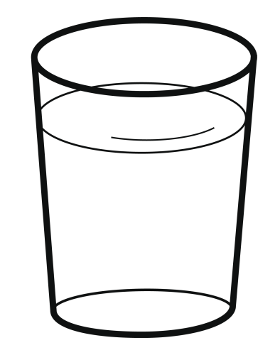 | 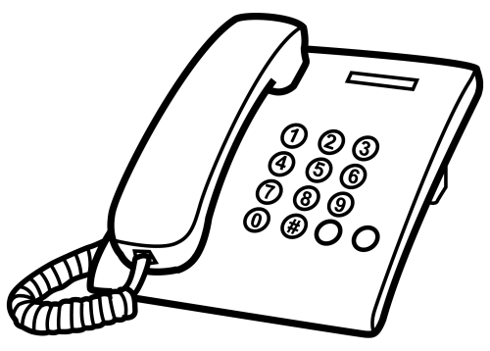
B_TA | _ASO | TELÉ_ON_
B_T_ | _A_O | __LÉ_ON_
_OT_ | V__O | ___É_O_O
_O__ | V___ | ___É___O
____ | ____ | ________

ARAÑA | VELA | LLAVE
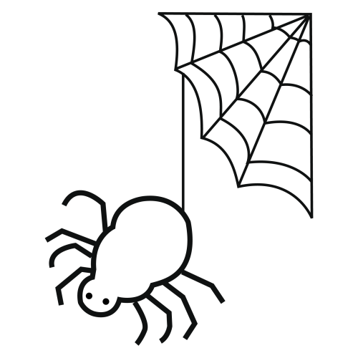 |  | 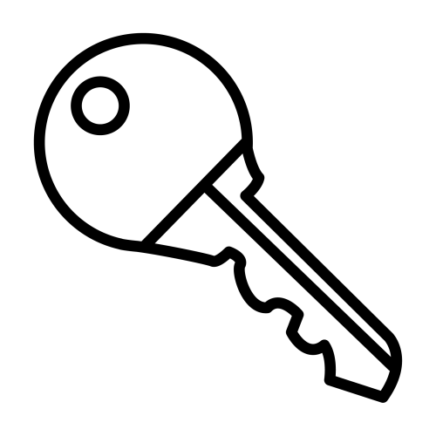
ARA_A | _ELA | LLA_E
__AÑA | V__A | __A_E
__AÑ_ | ___A | __A__
___Ñ_ | _E__ | ___V_
_____ | ____ | _____

PIÑA | BAÑERA | UÑA
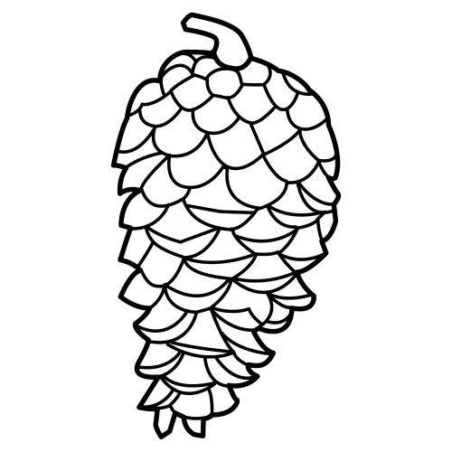 | 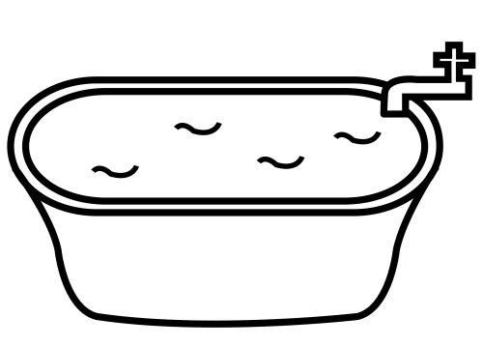 | 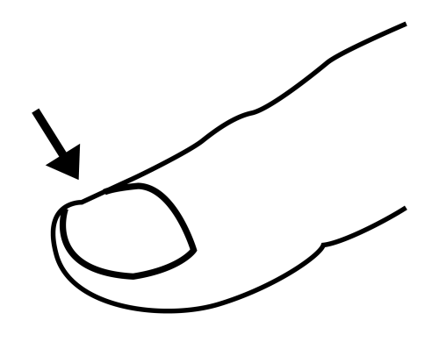
PI_A | VA_ERA | U_A
_IÑ_ | VA_E__ | U__
__Ñ_ | _AÑ___ | _Ñ_
P___ | __Ñ___ | __A
____ | ______ | ___

TOALLA | SOFÁ | SILLA
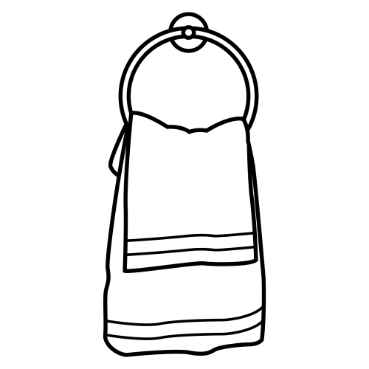 |  | 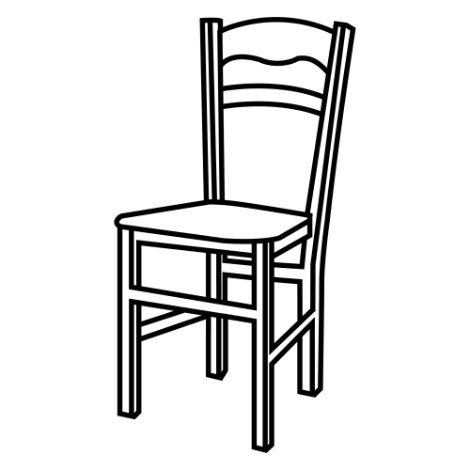
TOALL_ | SO_Á | _ILLA
T_ALL_ | _O_Á | _ILL_
_OA__A | _OF_ | S___A
__A___ | __F_ | ____A
______ | ____ | _____

RANA | RUEDA | PERRO
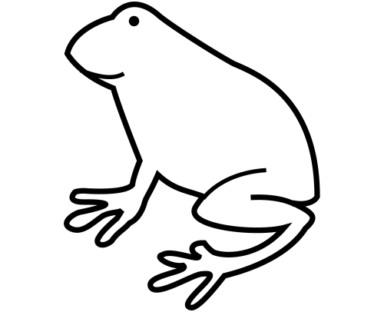 | 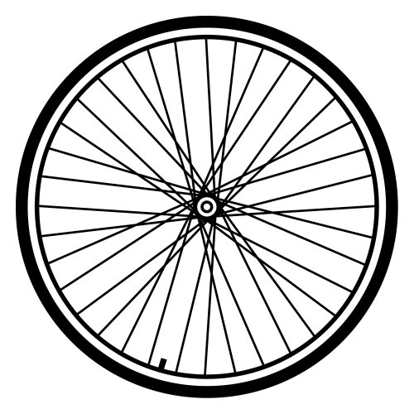 | 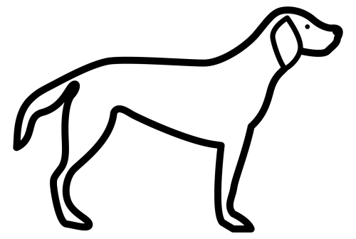
RAN_ | _UEDA | _ERRO
R_N_ | _UE_A | _ERR_
__NA | R__DA | PE___
___A | R____ | P____
____ | _____ | _____

RATA | ROSA | PAÑUELO
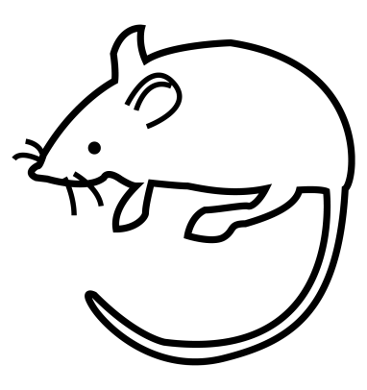 | 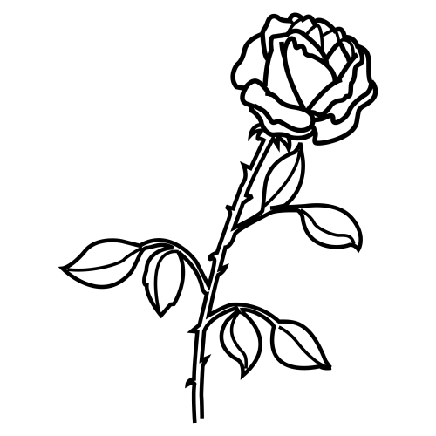 | 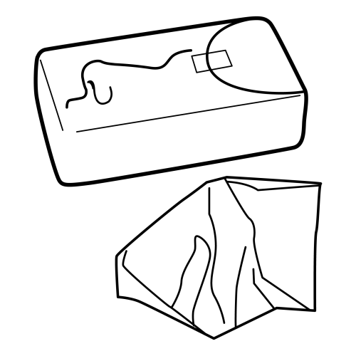
RA_A | _OSA | PA_UELO
_A_A | _O_A | PA_UE__
_AT_ | R_S_ | ___UE__
__T_ | R___ | __Ñ____
____ | ____ | _______

ZUMO | CEBOLLA | MOCHILA
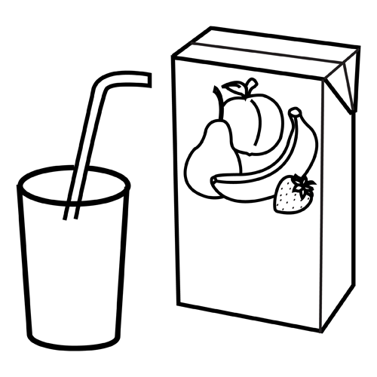 | 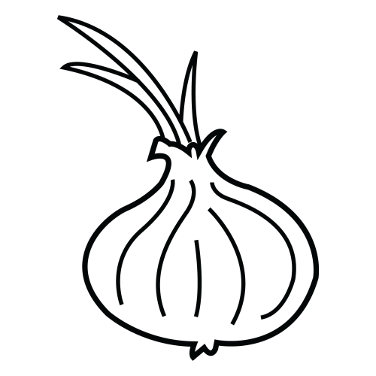 | 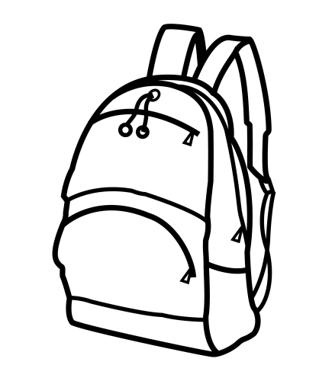
_UMO | __BOLLA | __CHILA
Z__O | __BO__A | ____ILA
Z___ | CE____A | MO__I__
_U__ | _E_____ | _O_____
____ | _______ | _______

ZAPATO | HOGUERA | CHIMENEA
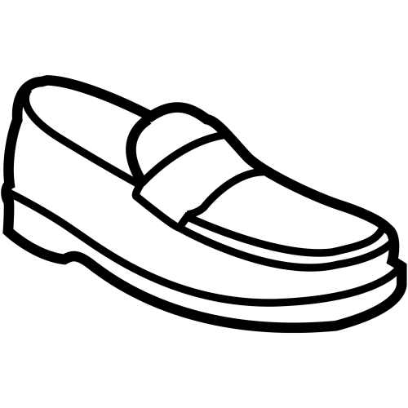 | 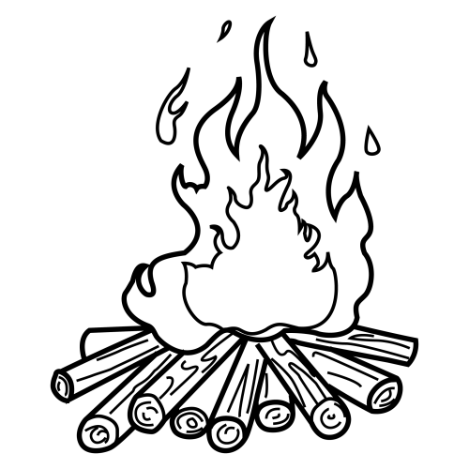 | 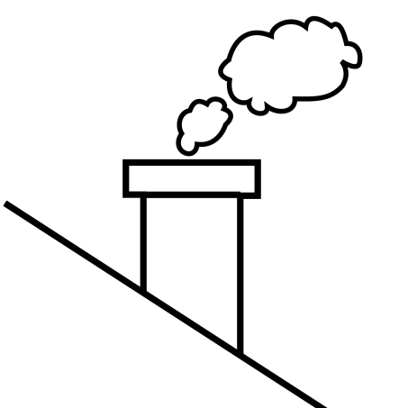
ZA__TO | __GUERA | __IMENEA
ZA__T_ | __G__RA | __IM__EA
_A_A_O | H____R_ | CH____EA
_A___O | _O_____ | ____E___
______ | _______ | ________

GUSANO | GALLINA | GUITARRA
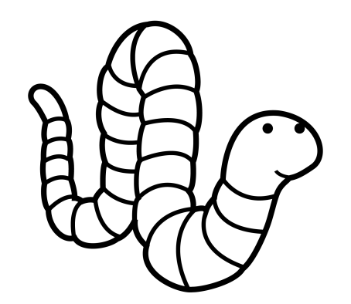 | 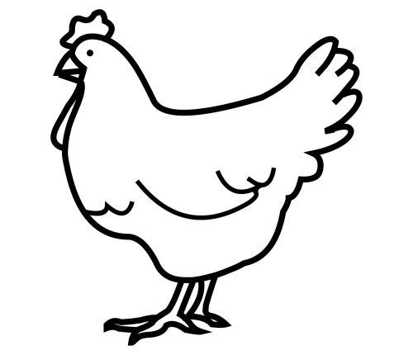 | 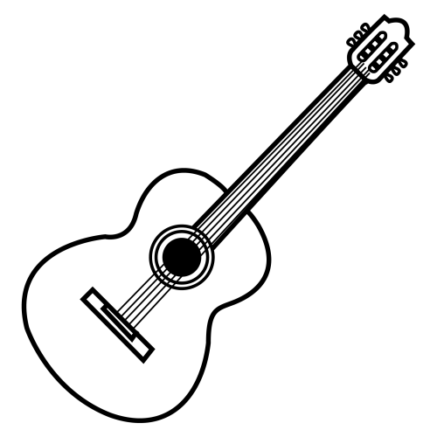
GU__NO | __LLINA | ___TARRA
_U__NO | __LL__A | ___TA__A
_US___ | GA____A | GU_T___A
__S___ | _A_____ | _U______
______ | _______ | ________

CABALLO | QUESO | MÁQUINA
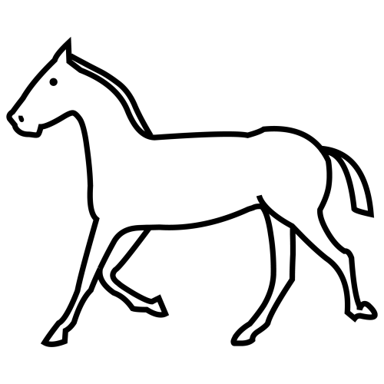 | 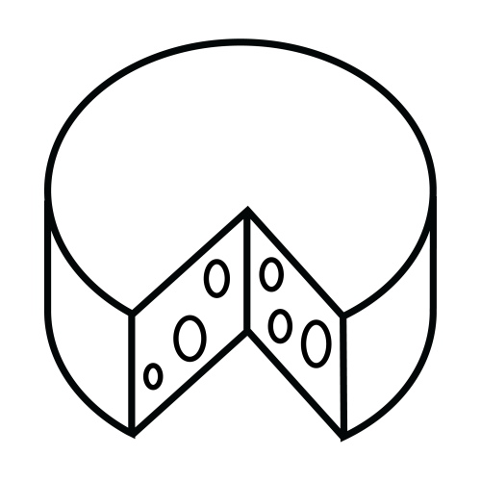 | 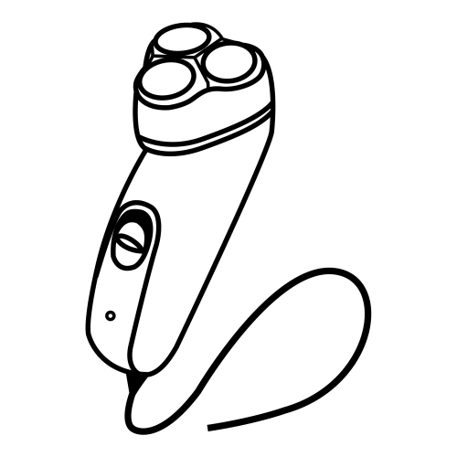
CA__LLO | QUE__ | __QUINA
CA__LL_ | __E__ | __Q__NA
__BALL_ | ___SO | MÁQ____
__BA___ | ___S_ | M______
_______ | _____ | _______

CUCHILLO | COCHE | ARAÑA
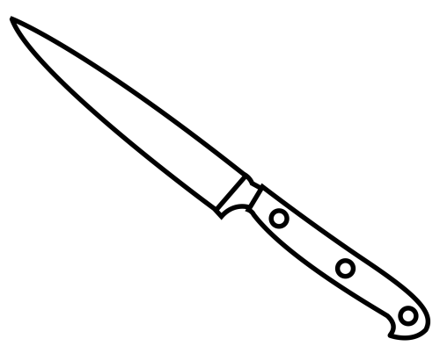 | 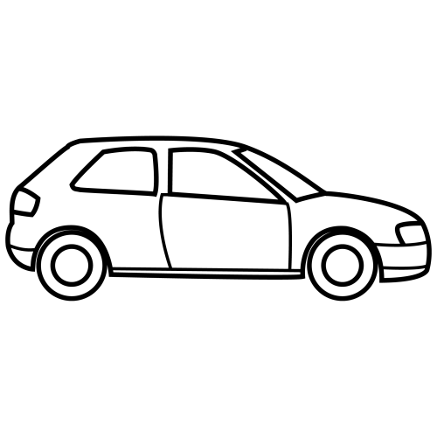
CUC__LLO | __CHE | ARA__
__C__LLO | __C__ | A_A__
__CHI___ | CO___ | ___ÑA
____I___ | _O___ | ___Ñ_
________ | _____ | ____ _

