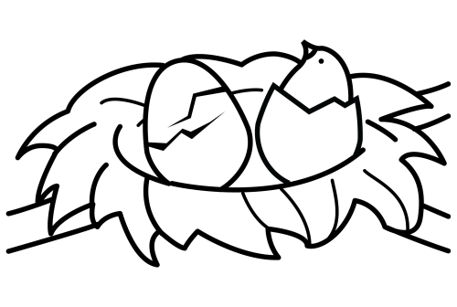 | NIDO | 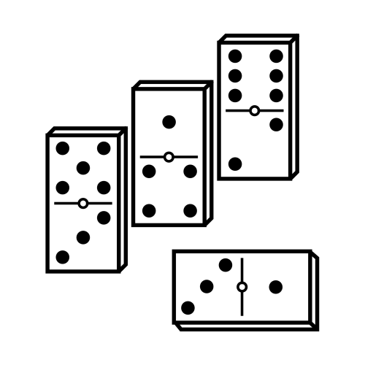 | DOMINÓ | 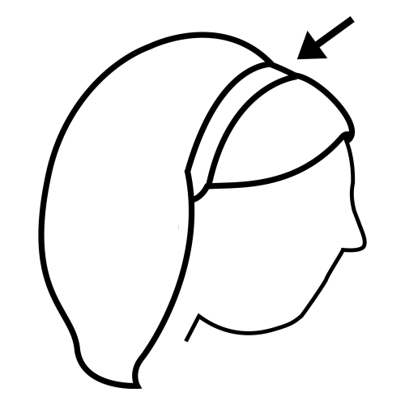 | DIADEMA
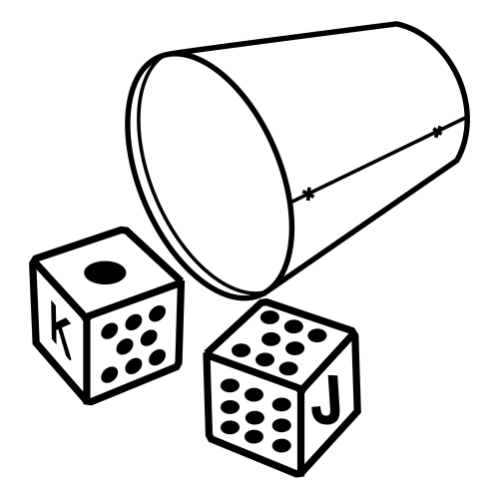 | DADO | 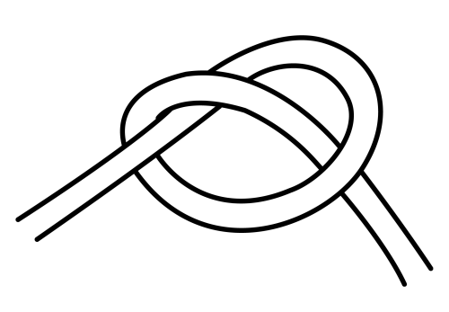 | NUDO | 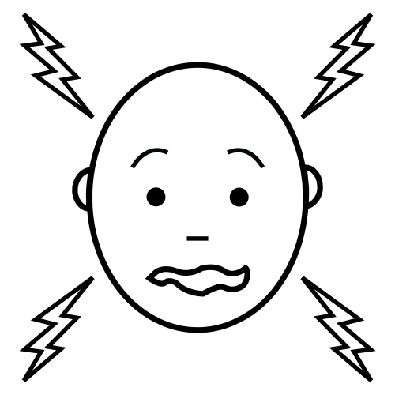 | DUELE
 | MONEDA | 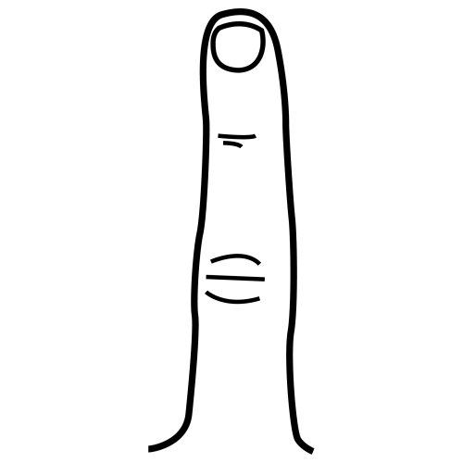 | DEDO | 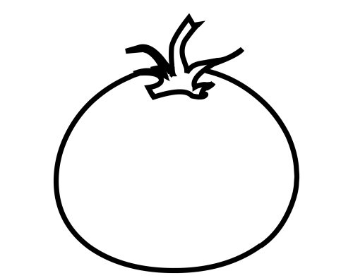 | TOMATE
 | DED_ |  | NID_ |  | D_DO
 | __DO |  | N_D_ |  | MON___
 | _IAD_M_ |  | __ELE |  | __DO
 | __MINÓ |  | M___D_ |  | D___
 | D____ |  | T_____ |  | D______
 | ______ |  | ____ |  | M_____
 | ____ |  | ____ |  | ____

 | NI | NE | O
 | DU | D | DA
 | N | U | LE
 | TO | E | DO
 | MO | MA | TE

NIDO
DUELE
MONEDA
NIDO
MONEDA
NUDO
TOMATE
DEDO
DUELE
DOMINÓ
DIADEMA
NUDO
TOMATE
DIADEMA
DEDO
DOMINÓ

N_D_ | M_N_D_ | D_D_
D__L_ | N_D_ | T_M_T_
D_D_ | D_M_N_ | D__D_M_

 | DO | MA | O
 | DE | MI | TE
 | MA | D | DA
 | TO | DE | NÓ
 | MO | LE | MA
 | DIA | NE | TA

_I_O | _O_E_A | _A_O
_UE_E | _U_O | _O_A_E
_E_O | _O_I_Ó | _IA_E_A

____ | ______ | ____
_____ | ____ | ______
____ | ______ | _______

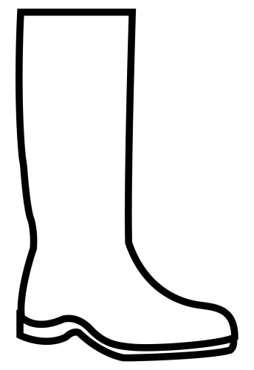 | BOTA | 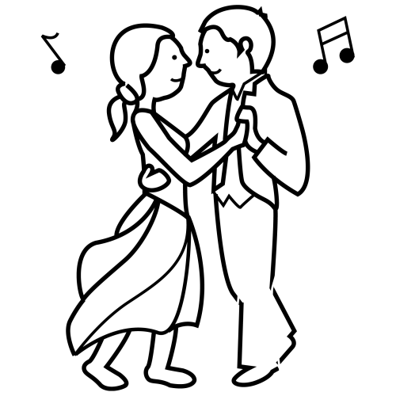 | BAILE | 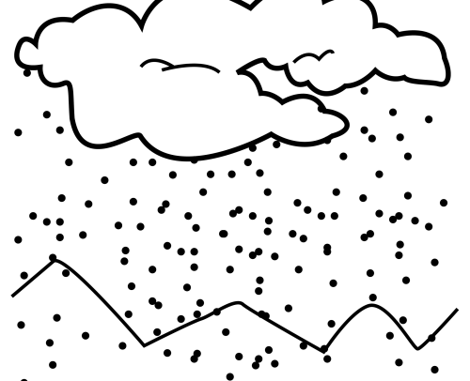 | NIEVE
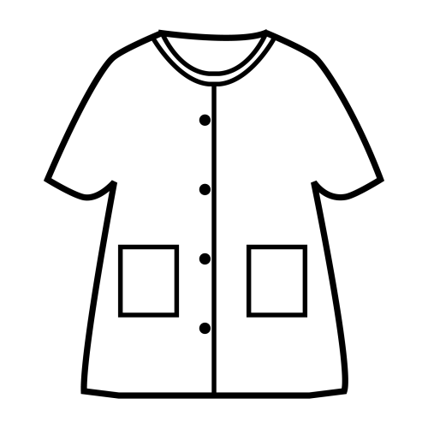 | BATA | 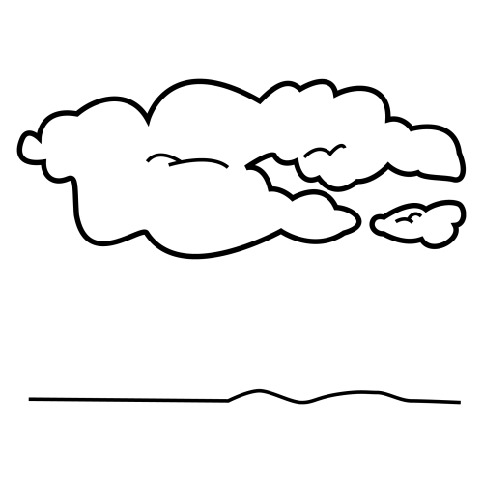 | NUBE | 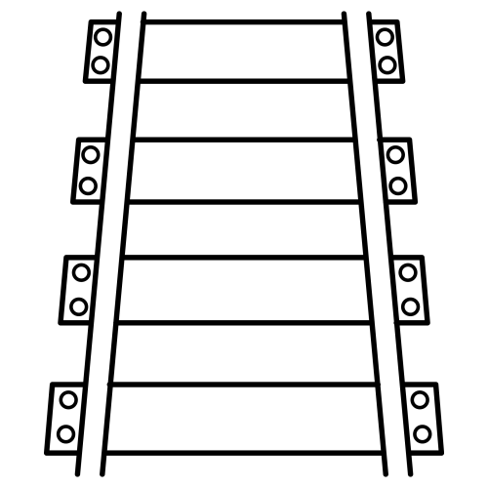 | VÍA
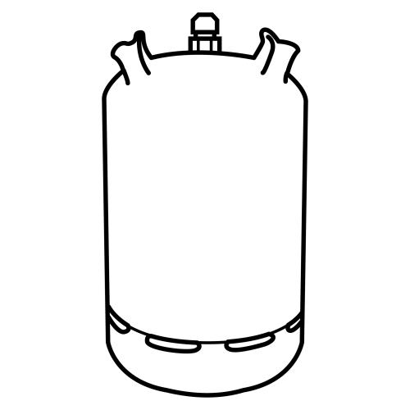 | BUTANO | 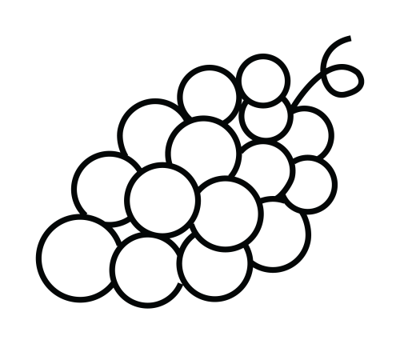 | UVA |  | MONEDA
 | M_NE__ |  | BUTA__ |  | __ILE
 | V__ |  | BO__ |  | NU__
 | BAI__ |  | MO____ |  | __A
 | NI___ |  | ___ |  | ___A
 | ____DA |  | _____ |  | BU____
 | __BE |  | ___ |  | _____
 | ____ |  | ____ |  | ___

 | BO | B | A
 | U | T | TA
 | B | A | A
 | NU | V | E

UVA
BOTA
NUBE
UVA
BATA
BOTA
BUTANO
NIEVA
NUBE
BAILE
BATA
VÍA
NIEVA
BUTANO
VÍA
BAILE

B_T_ | B_T_ | B_T_N_
_V_ | N_B_ | V__
M_N_D_ | N__V_ | B__L_

 | MO | TA | NÓ
 | DO | NE | NO
 | BU | E | VA
 | DIA | MI | DA
 | NI | DE | MA

_O_A | _A_A | _U_A_O
U_A | _U_E | _ÍA
_O_E_A | _IE_A | _AI_E

____ | ____ | ______
___ | ____ | ___
______ | _____ | _____

 |  |  |  |  |  | BO
 |  |  | PEI |  | BA | TA |  |  | BAI | BU
PA | TI |  | NE | TE |  |  | MA |  | LE | TA
LO |  |  |  |  | MO | LI | NO |  |  | NO
MA | MÁ |  |  |  | SU | MA
 |  | ……………………. |  |  |  |  |  | …………………….
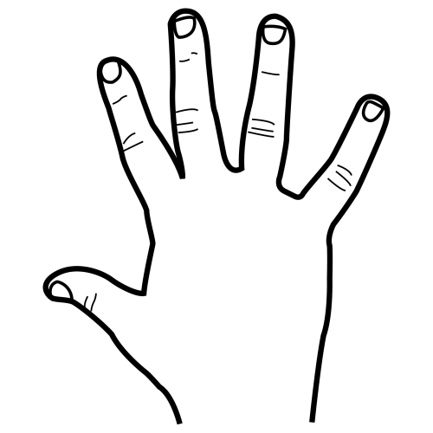 |  | ……………………. |  |  |  |  |  | …………………….
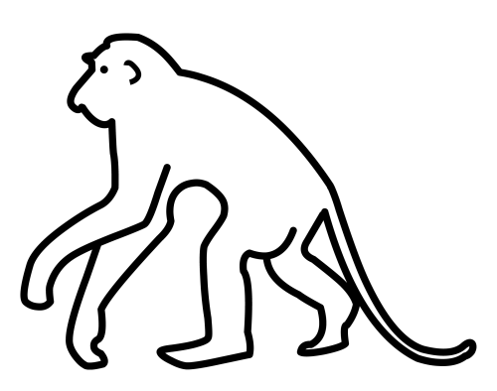 |  | ……………………. |  |  |  | 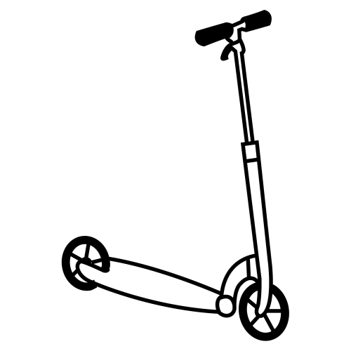 |  | …………………….
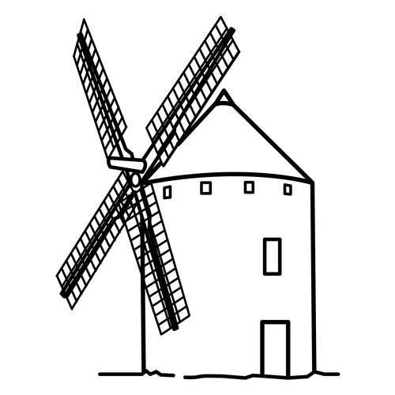 |  | ……………………. |  |  |  | 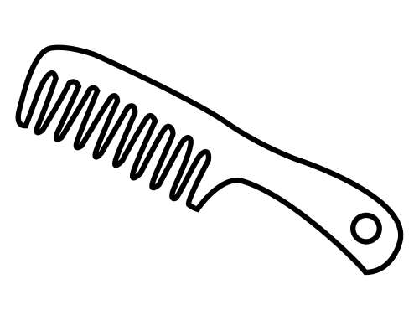 |  | …………………….
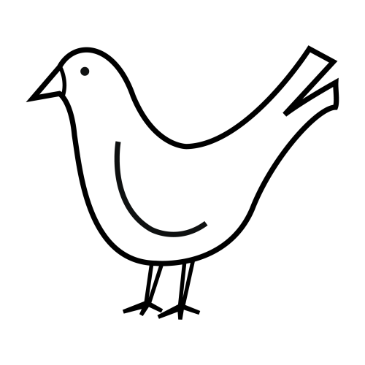 |  | ……………………. |  |  |  | 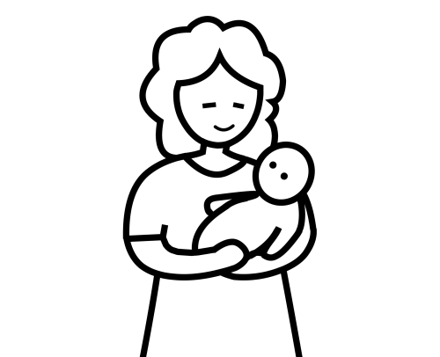 |  | …………………….
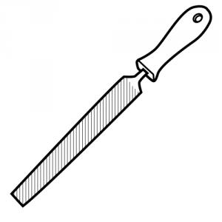 |  | ……………………. |  |  |  |  |  | …………………….
3 + 2 |  | ……………………. |  |  |  |  |  | …………………….

