 | LLAVE | 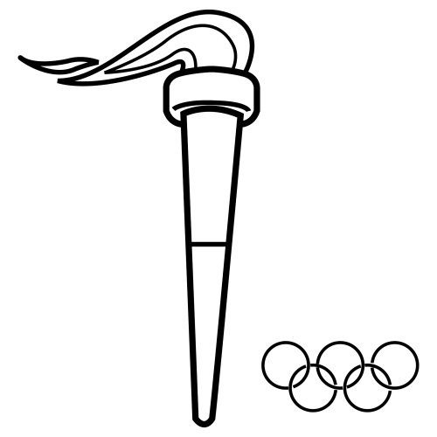 | LLAMA | 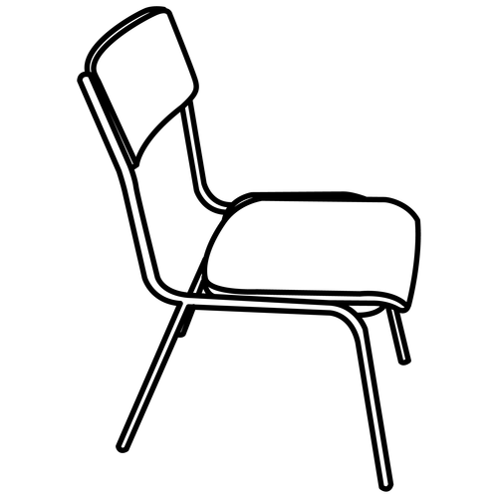 | SILLA
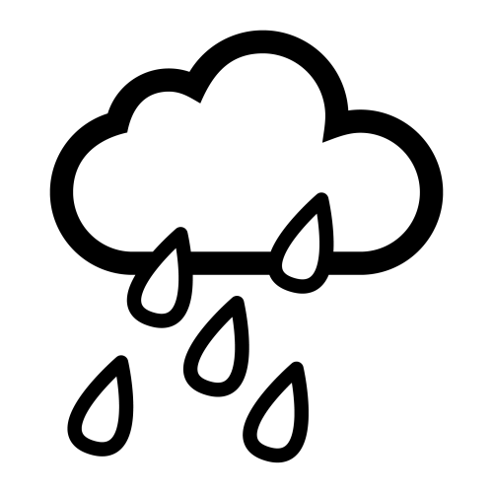 | LLUVIA | 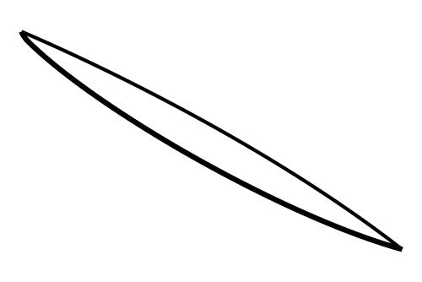 | PALILLO | 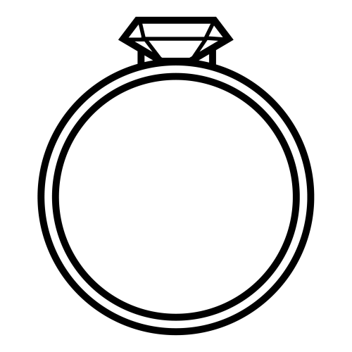 | ANILLO
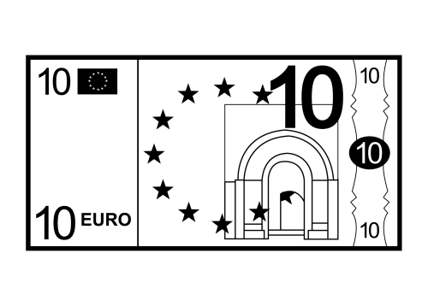 | BILLETE | 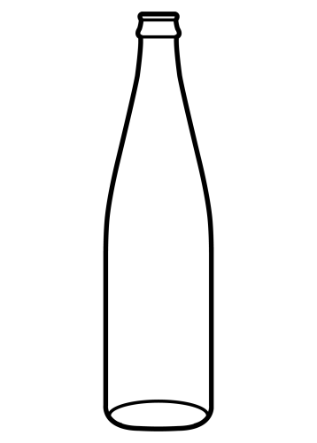 | BOTELLA | 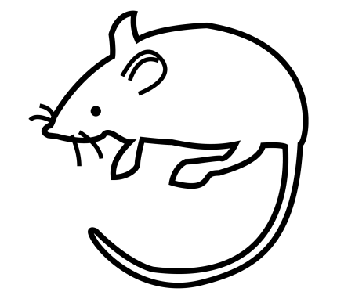 | RATA
 | PALI___ |  | LLA__ |  | LLA__
 | ANI___ |  | BILLE__ |  | ___VIA
 | BI___TE |  | ___LLO |  | __LILLO
 | ___V_ |  | LL__A |  | S___A
 | BOT____ |  | _____A |  | _____TE
 | ____ |  | BI_____ |  | BO_____
 | ______ |  | _______ |  | ______
 | _____ |  | _____ |  | _____

 | BO | NI | TE
 | BI | TE | A
 | A | LL | LLO
 | SI | LLE | LLA

BOTELLA
LLAMA
LLUVIA
BILLETE
LLUVIA
SILLA
BOTELLA
BILLETE
LLAMA
PALILLO
LLAVE
PALILLO
SILLA
ANILLO
LLAVE
ANILLO

LL_V_ | _N_LL_ | S_LL_
B_LL_T_ | P_L_LL_ | LL_M_
B_T_LL_ | LL_V__ | R_T_

_I__A | __A_E | A_I__O
__A_A | _I__E_E | _A_I__O
_A_A | _O_E__A | __U_IA

_____ | ______ | _____
_______ | _______ | _____
_______ | ______ | ____

 | LL | NI | LLO
 | A | A | LLA
 | BI | LI | LLO
 | SI | LL | VE
 | PA | LLE | A
 | BO | TE | TE

 |  |  |  | RA |  |  |  |  | LLA
 |  |  | BO | TA |  |  | O |  | VE | JA
BI | LLE |  | TE |  |  | A | JO |  |  | RRA
 | SI |  | LLA |  |  | NI |  |  | PE
 |  |  |  | PA | LI | LLO |  |  | RRO
 |  |  |  | TO
 |  | ……………………. |  |  |  |  |  | …………………….
 |  | ……………………. |  |  |  |  |  | …………………….
 |  | ……………………. |  |  |  | 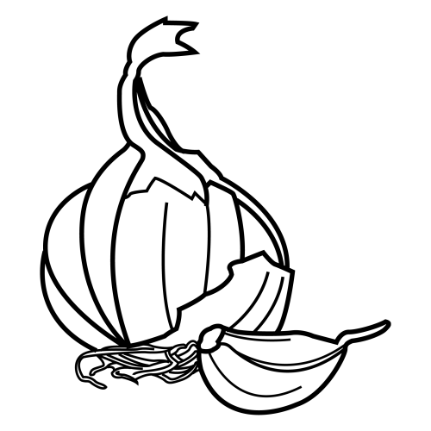 |  | …………………….
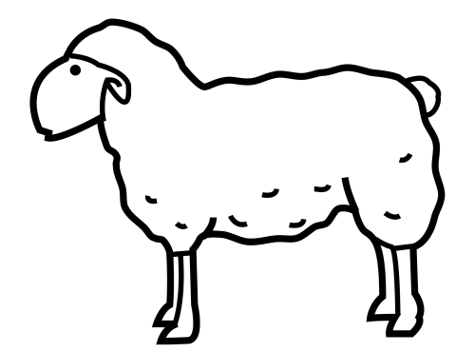 |  | ……………………. |  |  |  | 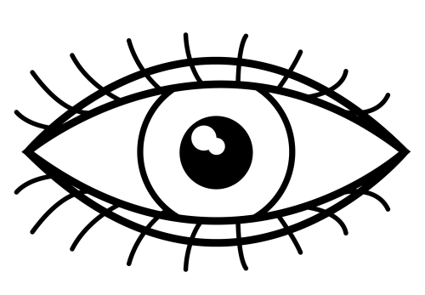 |  | …………………….
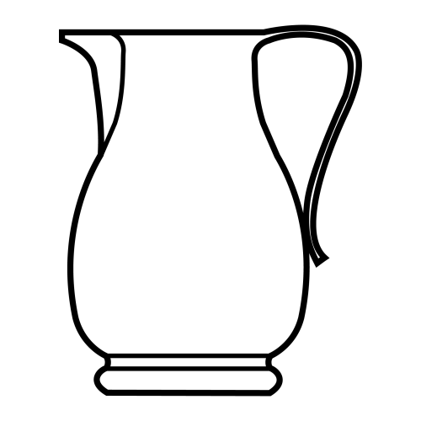 |  | ……………………. |  |  |  |  |  | …………………….
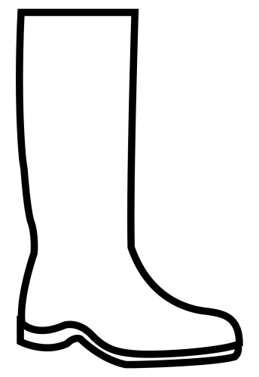 |  | ……………………. |  |  |  |  |  | …………………….
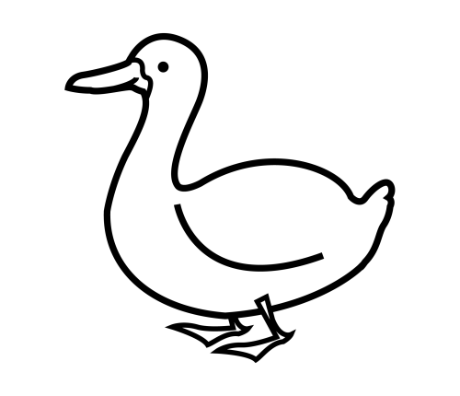 |  | ……………………. |  |  |  | 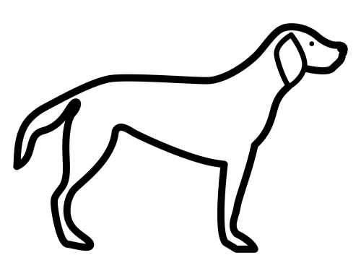 |  | …………………….

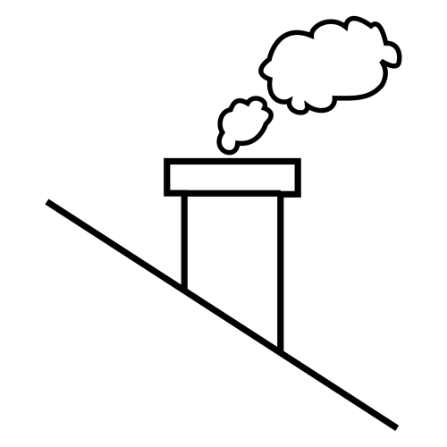 | CHIMENEA | 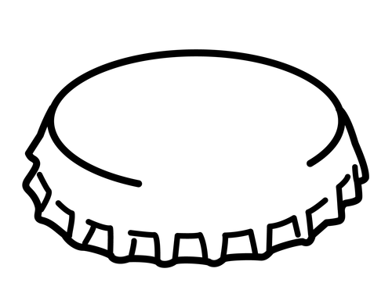 | CHAPA | 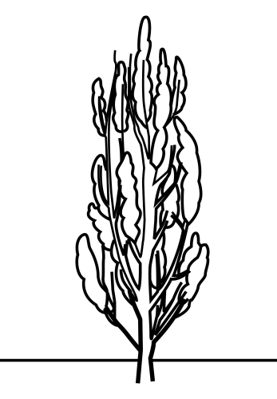 | CHOPO
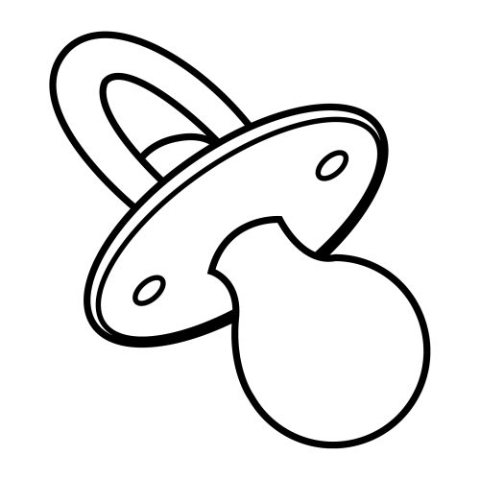 | CHUPETE | 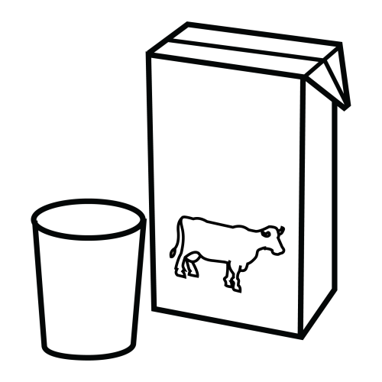 | LECHE | 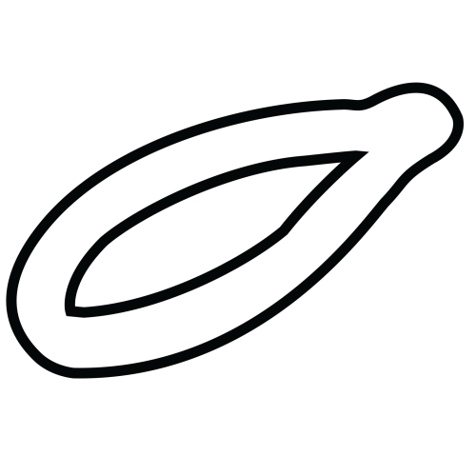 | CHURRO
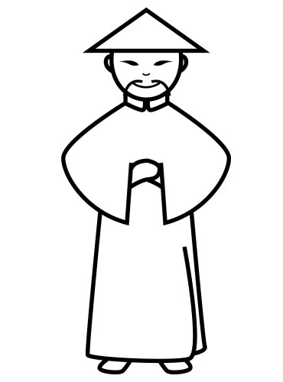 | CHINO | 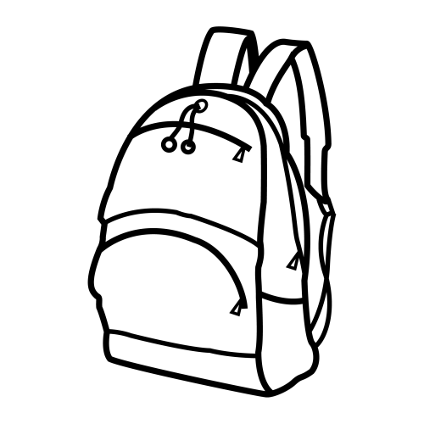 | MOCHILA |  | ANILLO
 | ___MENE_ |  | CHO__ |  | ___PETE
 | LE___ |  | CHUP___ |  | CHI_____
 | ___PA |  | MO_____ |  | ___NO
 | ____O |  | ANI___ |  | ___RRO
 | ___PO |  | ________ |  | _____
 | M______ |  | _____ |  | _____TE
 | ______ |  | A_____ |  | ____A

 | MO | NI | LLO
 | CH | CHI | RRO
 | CHU | E | LA
 | A | U | TE
 | L | PE | CHE

MOCHILA
CHOPO
CHINO
CHURRO
MOCHILA
CHINO
CHAPA
CHIMENEA
CHOPO
LECHE
CHUPETE
CHURRO
CHUPETE
CHAPA
CHIMENEA
LECHE

CH_P_T_ | L_CH_ | CH_RR_
CH_P_ | M_CH_L_ | CH_N_
CH_M_N__ | _N_LL_ | CH_P_

__U__O | _E__E | __U_E_E
__I_O | _O__I_A | __O_O
__A_A | A_I__O | __I_E_EA

_____ | _______ | ______
_______ | _____ | _____
______ | ________ | _____

 | CHI | NI | LLA
 | A | TE | TE
 | PA | ME | LLO
 | BO | LLE | LA
 | CHU | LI | NEA
 | BI | CHI | LLO
 | MO | PE | TE

CHO | PO |  |  |  |  |  | SI |  | LLA
 |  |  | CHI | ME | NE | A |  |  | VE
BU | TA |  | NO |  |  | NI |  |  |  | BI
 |  |  |  | PA | LI | LLO |  |  |  | LLE
MO | NE |  | DA |  |  |  | CHU |  | PE | TE
 |  |  | DO |  |  | PE | RRO
 |  | ……………………. |  |  |  |     
                

